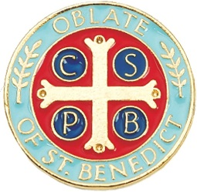
BRISTOW DEANERY MEETINGS 2025-2026

This year we will be using “Radical Hospitality: Benedict’s Way of Love” by Lonni Collins Pratt, OblSB and Father Daniel Homan, OSB.
The book is readily available at bookstores, Amazon, etc., at a print price of $19.98. A limited number of the books are also available from the Oblate Office beginning August 15. The discounted price is $12. Contact Kathy Frick if you would like to reserve a copy.

Our monthly meeting format:
9:30 AM Morning Prayer with the Sisters
10:00 AM Meeting with presentation and discussion
11:45 AM Midday Prayer with Sisters
12:15 PM Lunch (optional)
1:00 PM Inquirers’ Meeting and Novice Formation Class (approx. 45 min.)

We are hopeful that some of the Sisters will act as presenters this year. The designated monthly chapters and names of the presenters will be posted closer to the September meeting. As always, we ask everyone to RSVP if they are planning to attend a monthly meeting and also indicate whether they will be staying for lunch.

2025:
September 13
October 11 Oblate Education Day - Multipurpose Room
November 8
December 13

2026:
January 10
February 14
March 14
April 9-11 Novice Discernment Retreat (Novices only)
April 11
May 9 Annual Oblate Ceremony – Monastery Chapel

Presenters;
SKP – Chapter 8 (Easy to Love)
S. Kay –
S. Joanna -

